**1. You should include a brief description of what you originally proposed and what changes you needed to make to your original proposal (and why you made them).**

I simulate a gymnastics high bar dismount. This system has **two rigid bodies with volume and mass**. Body B models human arms and Body D models a human torso which are represented with real lengths, widths, and masses.

The simulation involves two phases.

Phase One (Simple Double Pendulum):

Bodies start vertically upright with initial angular velocities. Body B is constrained to rotate about the high bar (2.8m high). Simulation runs until the specified release angle α of Body B is reached.

Phase Two (Projectile):

The constraint on Body B is released. Both bodies fly off the high bar. Plastic impact is detected when the bottom of Body D hits the ground. Simulation is successful when impact is detected on both corners of Body D simultaneously and verified by animation.

Changes Since Proposal: Added volume to bodies (rotational inertia requirement), made impact plastic instead of elastic (model more accurately).

**Code:** [**Simulation Code (takes ~6 minutes to run)**](https://colab.research.google.com/drive/1fWydLiNMf7LJ5YuA3Pz6bff2UwE2u_9s?usp=sharing)

<https://colab.research.google.com/drive/1fWydLiNMf7LJ5YuA3Pz6bff2UwE2u_9s?usp=sharing>

**2. You should include a drawing of the system you are modeling that includes all the frames you are using, with frame labels. In addition to the drawing, you should include all of the rigid body transformations you are using between the frames. These frames and their labels should be clearly identifiable in your code.**

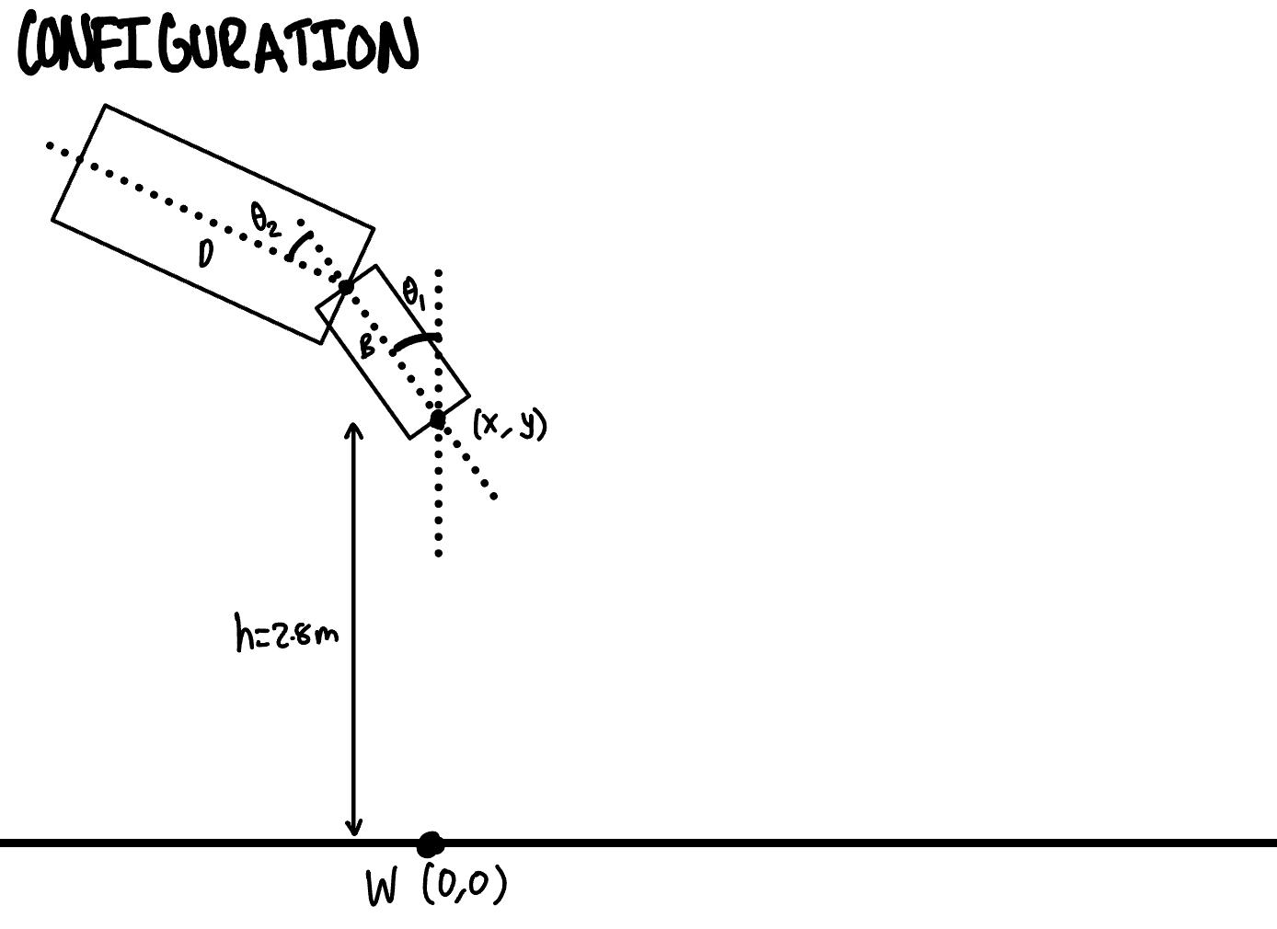

q = [x, y, θ1 θ2]

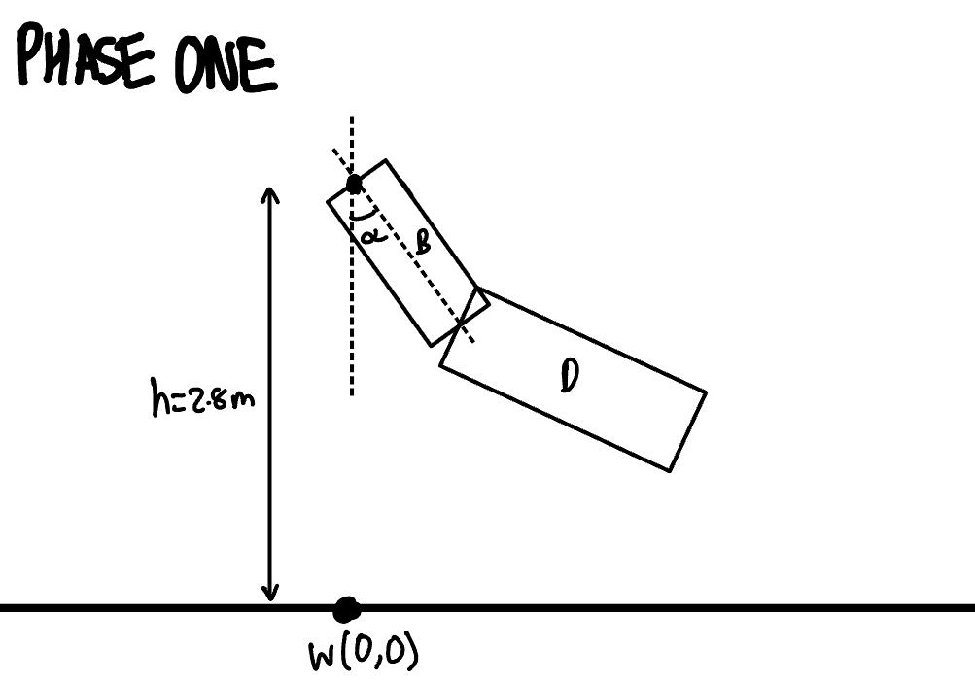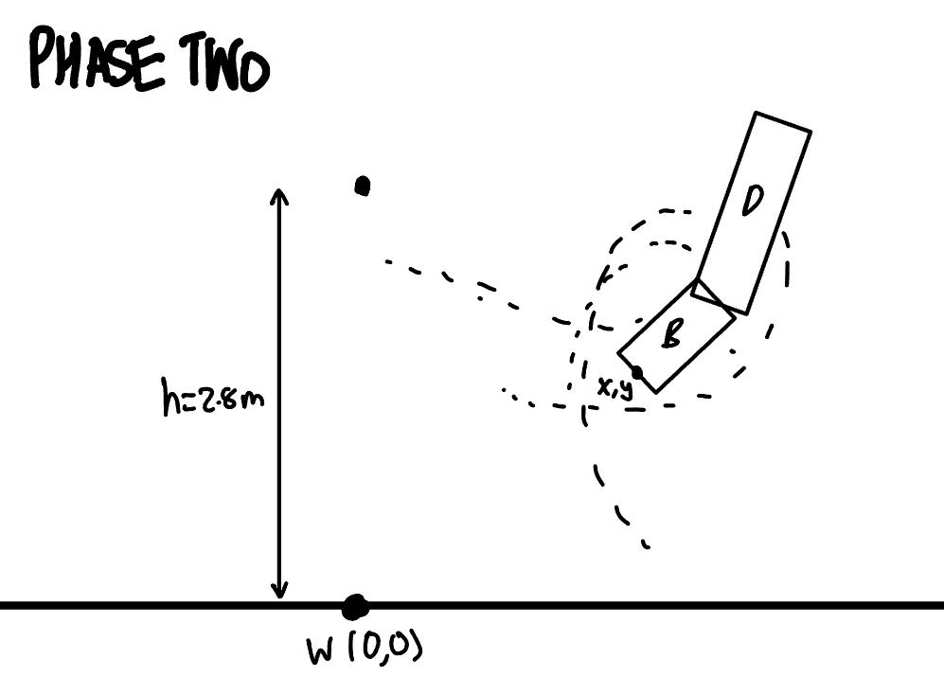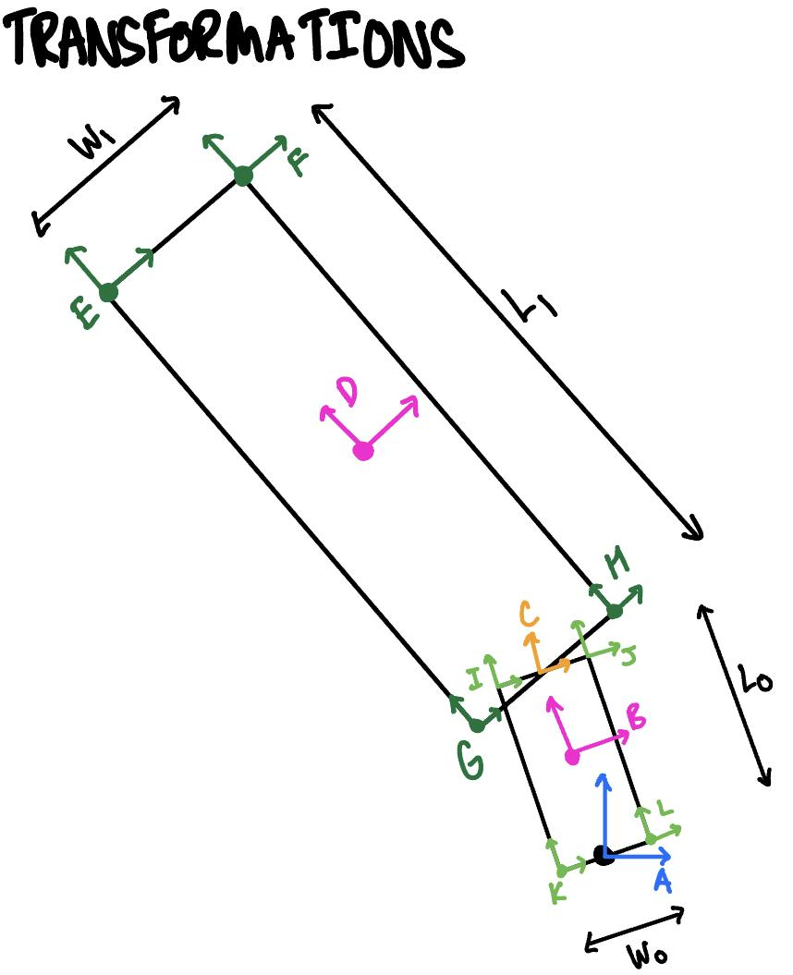

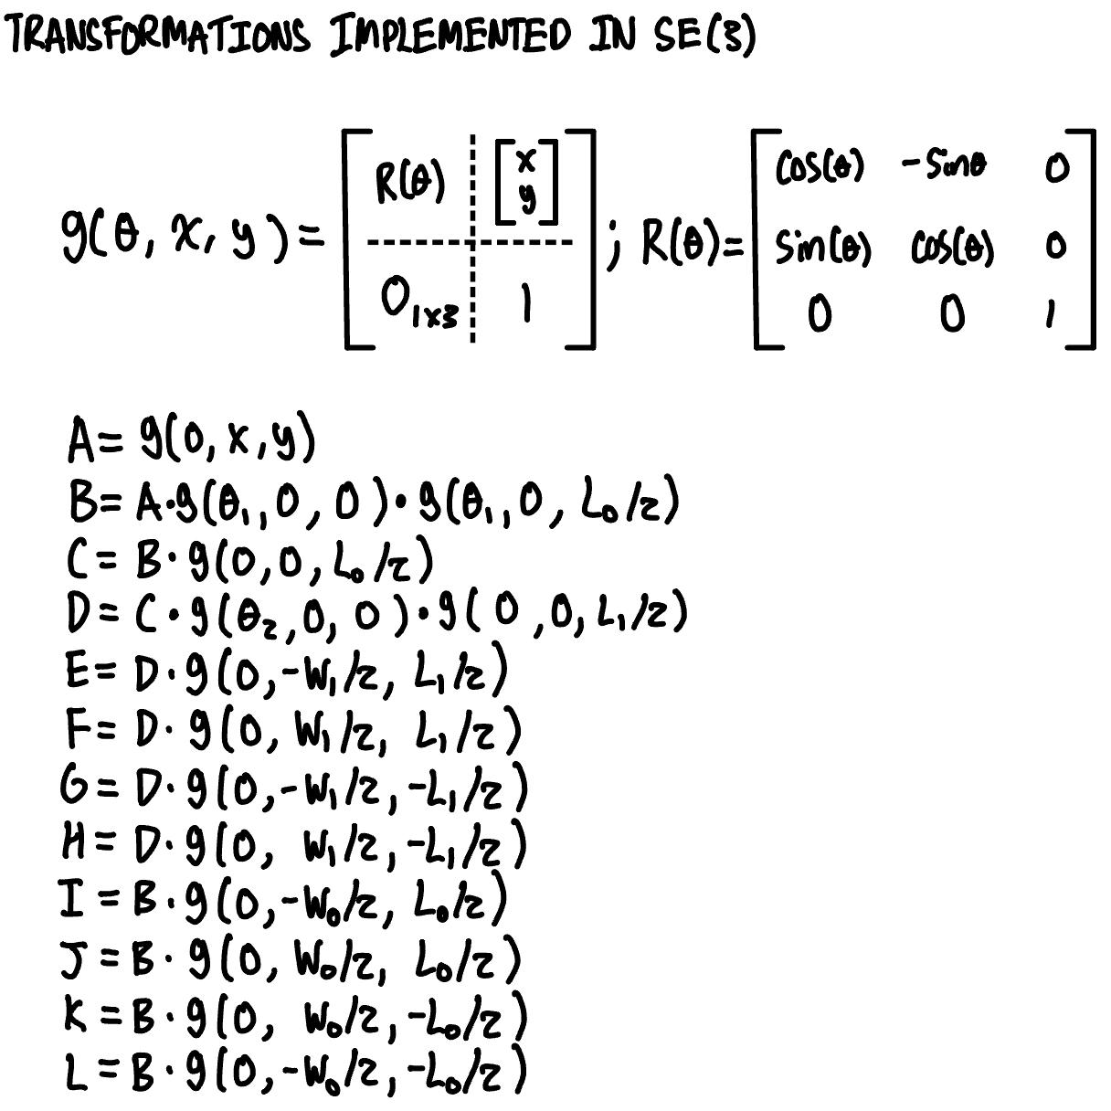

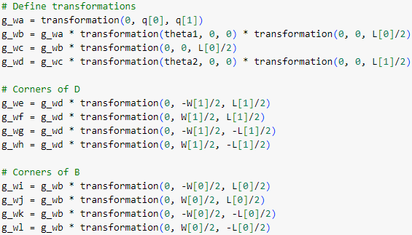

**3. Using the drawing and the rigid body transformations, you should say in writing how you calculate the Euler-Lagrange equations, the constraints, the external forces and impact update laws.**

There are differing approaches to each phase.

Phase One

The Euler-Lagrange equation, two constraints on x and y, and constant frictional/drag force are solved symbolically, lambdified and simulated until θ1 > α. The constraints are Φ1=x and Φ2=y-2.8. The frictional/drag force is F = [4,4,0,0]. This means there are 6 unknowns (x, y, θ1, θ2, λ1, λ2) and 6 equations.

It is simulated with timesteps of 0.0001 in order to accurately release at the correct angle. This was needed as timesteps may pass the release angle by too much.

Phase Two

There are no constraints and the Euler-Lagrange equation is calculated but cannot be solved symbolically due to computational limitations. Therefore, during simulation, the Euler-Lagrange equation is solved numerically using sympy nsolve(). Second time derivatives from the previous iteration are passed as initial guesses for this function. The initial condition of Phase Two is the system state from the last timestep of Phase One.

Impact is detected when the y of transformations E and F are negative which is the Φ condition used. The impact is plastic so solving for the hamiltonian is not necessary. Instead the time derivative of the system state (velocities) perpendicular to the impact condition has to be 0. Additional impacts for each of the corners of all bodies could be implemented in a similar manner to that done to E and F, however, were not necessary for a successful simulation (landing on your feet) and therefore were not implemented.

**4. If your code works, you should describe in words what happens in the simulation and why you think it is correct (e.g., at a high level, describe why you think the behavior is reasonable or not). If your code works, this can be the end of your write-up. If your code works, your entire write-up will likely just be a few paragraphs.**

The simulation works and is accurate. The simulation begins in the intended initial configuration and the lengths and widths of the bodies are correct. During Phase One, the pendulum constraint is enabled. The pendulum releases at angle alpha as confirmed by logs.

During Phase Two, when transformations E and F hit the ground at the same time, the simulation prints “Stuck the Landing” to confirm the successful run. When one point hits the ground but not the other the the impact behaves plastically. The system flies and rotates as expected like a gymnast.

It was discovered that with initial angular velocities of 0.6 and 1.6 rad/s for θ1 and θ2 that a release angle of 36 degrees to allow the gymnast to land upright with one rotation in the air. The landing position is also similar to the “stick” position where the arms are in front for balance.